Dead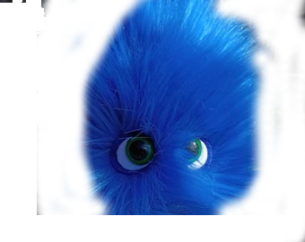

Pancreas

Society Cup
Date 30/11/2024
Where
The Ashbridge Inn, Avondale Rd, Pontrhydyrun, Cwmbran NP44 1DE
Cost
£20 a ticket payment to PayPal @Briantre

You Get
3 games of the best game in the world
4 jelly babies
Lucky blue gem
Jeffers the Gonk

You Bring
Fully painted team (minimum 3 colours) numbered and skills marked
Ball
Dice
Pitch
Rules
Blood Bowl Second Season (2020) Rule Set
All Races in the Rulebook, Teams of Legend, & NAF additional

All injuries reset after each game
Apothecaries work as described in the Rulebook

You Are Given 1,200,000 Gold To Build Gold To Build Your Team
You may purchase players, rerolls, fan factor, coaches and cheerleaders as normal with this money

Wizards, Journeymen, Special Play Card and Mercenaries are NOT ALLOWED
You may purchase any other inducements for your team, including star players
Note: If you are including a star player, you must have 11 players on your team BEFORE hiring him/her. Having 10 players and a star player is NOT ALLOWED.
Remember: You Can Not have the same star player as your opponent. If both of you attempt to field the same player, then that star player has swindled both of you!! Neither of you can field them. Also, you cannot use Igors or Apothecaries on star players.
All star players from the Second Season Edition and subsequent Spike Journals will be allowed. Second Season Edition has given star players each there own “Special Rule”. If you have a star player on your roster, you are expected to explain the “Special Rule” to your opponent. Please use the blue gem to represent when the Star Player has spent his/her special rule.
Skills
Each team has 48 spp to distribute amongst their team. No random skills and no stat increases.
Players can take singles, doubles and stack skills as per the spp cost in the Advancements table.
Start time
9.30 to 10.00
1st game 10.00 to 12.15
12.15 to 13.00 lunch
13.00 to 15.15 game 2
15.15 to 17.30 game 3
17.30 trophy’s, thank you and goodbye
Will be using tourplay to track games
House Rules
After kick-off but before the drive, one random player on each team suffers a hypo and turns into Jeffers the Gonk. MA 5 ST 1 AG 3+ PA – AC 6+ Dodge, Side Step, Stunty, Titchy, Dirty Player +1, Sneaky Git, No Hands. Once drive is over Jeffers the Gonk will return back to normal. Repeat kick-off event again with another player turns into Jeffers
Poop chanting is encouraged…
Thanks Brian

Scoring
3 points for a win
1 point for a draw
0 points for a loss

